**IntroGIS**

**Assignment Week 05**

In this week’s exercise, we will continue to use the maps basemaps from Tigerline Census data.  We will also use data that is available from the Westchester County GIS Website. The objectives of the exercise are to

* Explore proximity by
  1. Using the selection criteria to create new layers and views of the data.
  2. Creating selections which are within a layer and go between layers
  3. Creating selections by location.
  4. Creating buffers which are a measure of proximity
  5. Set Label Zoom Scale

There is a step-by step video in the folder for this week.

**Gathering layers and data**

1. Create a folder for Week05 in the directory path *X \yourlastname\week05*
2. Navigate to the US Census Tigerline Data Download Web Interface:

<https://www.census.gov/cgi-bin/geo/shapefiles/index.php>

1. Select
   1. Year: 2010
   2. Layer Type: County Subdivisions
   3. County Subdivision: 2010 New York
   4. County: Westchester
2. Select Download and put the zip file in your Week05 folder. Unzip it.
3. Return to the *Main Download Page (*a link in the middle on the right)
4. Go through the same download process for
   1. Roads *tl_2010_36119_roads*
5. Choose “All Roads” to get them by county.
6. **NOTICE:** In the pull down menu are the layers from the first ArcMap assignment (area landmarks, point landmarks, water).
7. Navigate to the Westchester County GIS Data Warehouse:

<https://giswww.westchestergov.com/wcgis/DataWarehouse.htm>

1. Select *County Data Download*
2. Select *Community Facilities*
3. Select the shapefile icon for Hospitals and unzip the shapefile in your week05 folder. It’s name is *wchosp.*

**Find Counties that I-684 runs through**

1. Open a new map.
2. Set the initial map characteristics
   1. *Data Reference –make it easier to share map folders*
      1. File->Map Document Properties->Check “Store relative pathnames to data sources
   2. *Page Layout – set to landscape or portrait*
      1. Layout icon->ISO A4 Landscape/Portrait or Letter (ANSI A) Landscape/Portrait
   3. *Map Background Color- Set background color for more professional looking map*
      1. *Right Click Layers->Properties-Frame tab->Set the background color*
   4. *Coordinate System – necessary for earlier versions of ArcMap*
      1. Right Click “Layers” in the Table of Contents panel at the left. Choose Properties and go to the Coordinate System tab.
         1. In the top window expand Geographic Coordinate Systems
         2. Expand North America
         3. Expand USA and territories
         4. Select NAD83

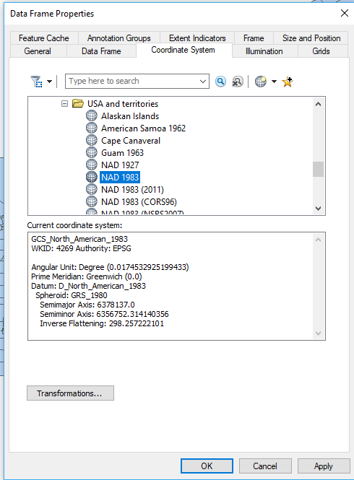

* + 1. Click “OK” to set the coordinate system.

1. Add the shapefiles for
   1. County Subdivisions *tl_2010_36119_cousub10*
   2. Roads *tl_2010_36119_roads*
   3. Hospitals wchosp
2. Rename the layers
   1. *tl_2010_36119_cousub10 Westchester Towns*
   2. *tl_2010_36119_roads Westchester Roads*
   3. *wchosp Westchester Hospitals*
3. Save the Map: *yourlastname-I684.mxd*
4. In *Layout View, u*sing the “Insert” menu item (at the top), add a Title (“I-684 Counties, Your Name, Date), Legend, Scale bar and North Arrow and export the image to *yourlastnameWestchesterbasemaps.jpeg*
5. NOTE:
   1. you may want to resize. Use the regular zoom tool (not the one which resizes the layout view map)
   2. the title in the map is where we are going (I-684)
   3. you may have to change the orientation

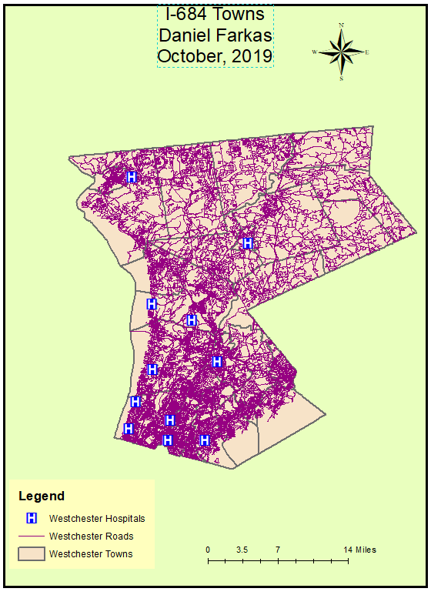

1. Go back to data view (View->Data View).

**Selection by Location**

We want to find towns that Interstate I-684 goes though. To this we first have to select the towns in Westchester, and then select the towns that “intersect” I-684.

***Select by location. Find the towns that I-684 runs through***

* 1. First we select the I-684 line segments
  2. Open the Attribute Table in Westchester Roads and look at the “FULLNAME”; close the attribute table.
  3. Scroll down looking for ‘I- 684’
  4. **NOTE: there is a space after the “-“. Surely this was not originally intended.**
  5. Selection by Attribute (from top tool bar)
  6. Make sure the Westchester Roads layer is selected (“Layer” text box at top)
  7. Set the query to “FULLNAME” = ‘I- 684’ (single and double quotes necessary)
  8. You should see I- 684 highlighted in blue
  9. Create a layer of I-684 (right click Westchester Roads->Selection->Create layer…)
  10. Name the Layer I-684
  11. Clear the selection (Selection->Clear Selected Features)
  12. By clicking on the polygon or line icon under the layer name you can change color so that it’s easier to see the layer features (e.g. bright red). Make I-684 stand out by making it wider and a different color. Click the line and in the dialog box change the color and width. You may have to experiment a bit to get it to look good, but the first choice in the dialog box for Highway will work.
  13. In Layout view, with only the WestchesterTowns and I684 layers turned on, export the map image as *Westchester-I684.jpg* to show Background Color, Title, Legend, Scale Bar and North arrow
  14. NOTE. The order of the layers in the Table of Contents to see everything should be Westchester Hospitals (turned off for now) I-684, Westchester Roads, Westchester Towns.

1. Now let’s identify the towns that I-684 goes through:
   1. Selection (from top tool bar), select by location
   2. Set the query dialogue to:
      1. “select features from”
      2. Westchester Towns layer (target)
      3. The I684 should be in the Source text box
      4. Target layer(s) features intersect the Source layer feature”
      5. Click Apply

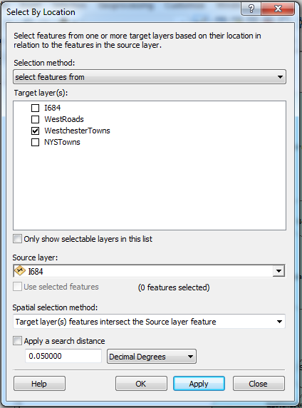

* 1. You should see the towns selected that contain or intersect I-684. If so, click OK.
  2. Make a layer of the towns that intersect I-684 and turn on labels (Right Click Westchester Towns->Selection->Create layer from selected features. Set the color so that it is different from any other polygon layer. Rename the selection layer to “I-684 Towns”.
  3. **Clear the selections, make sure all the roads and I-684 are visible (move layer above the selected towns).**
  4. **If you have to, change the color of I-684 (and maybe the size). Single click on the symbol for the layer will open the color dialog.**
  5. **Make sure the order of the layers is Westchester Hospitals (still off), I-684,Westchester Roads, I-684 Towns, Westchester Towns.**
  6. Export the map image as *I684Towns.jpg* in display view to show title, scale bar, legend and north arrow (modify the title to reflect what the map shows). Go back to data view

1. Save the map (*yourlastnameI684.mxd*)

**On Your Own**

In this exercise, we will create a map that shows Hospitals and the towns that contain hospitals.

1. Create a new map by “Saving as”. Call it *yourlastnameHospitals.mxd*
2. Turn on layers for the Towns, Roads, I-684 and Hospitals
3. You may want to change the “symbology” to make the hospitals more visible (color, size shape). If you click on the symbol, the color/size palette opens. If you scroll down about half-way you will find a Hospitals Icon.
4. Create a layer of towns that contain hospitals in the same way you created the layer of towns that intersect I-684:
5. There is one difference. In the Search by location dialogue box:
6. Target layer: Westchester Towns
   1. Source layer: Hospitals
   2. Spatial selection method: “contain the source layer feature.”
7. For the selection, create a layer of towns with Hospitals (and clear the selection).
8. The order of the layers should be Hospitals, I-684, Westchester Roads, Hospital Towns, Westchester Towns. Turn off the I-684 Towns
9. For the Hospital Towns, you can change the color and widen the border to make them stand out. Single click the color in the table of contents and set border to 3.
10. Revise the Title and add Scale Bar, Legend and North Arrow Submit a jpeg of the new map (WestchesterHospitals.jpg).
11. Save the map (*yourlastnameHospitals.mxd)*

**Analyzing proximity**

Create a map that shows the proximity of Hospitals to I-684. There are several ways to do this. One will use selection by location to select the proximate hospitals. The other will create a buffer layer around I-684.

**Layers needed:**

* I-684Westchester Hospitals
* Westchester Hospitals
* Westchester Towns
* Westchester Roads

**Basic Steps**

1. Start a new map by “Saving As” *yourlastnameProximity.mxd*
2. Turn off the Hospital Town layer.

**Proximity with Selection by location**

1. Choose Selection by Location (from the Selection menu at the top).
2. Source is I-684, Target is “Hospitals”, type of selection is “are within a distance of the source layer” to 6 Miles

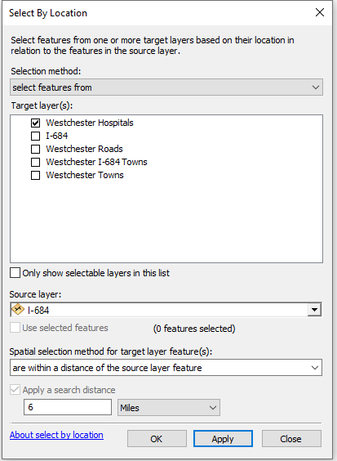

1. When the selection comes up – make a layer of the selected points and clear the selection. Make sure the regular hospitals and the selected ones have different symbology (color and size). Make sure the new hospital selection layer is on top of the original hospitals layer (otherwise we can’t see it).
2. Rename the Hospital Selection layer *I-684 Hospitals.*
3. In display mode, add annotation (Title, etc.) and export as jpeg, *I684Hospitals.jpg*
4. Save the map.

**Proximity using a buffer**

1. Return to Data View.
2. Open up the Toolbox (red toolbox icon at the top).
3. Expand *Analysis Tools ->Proximity*. Double click *Buffer*

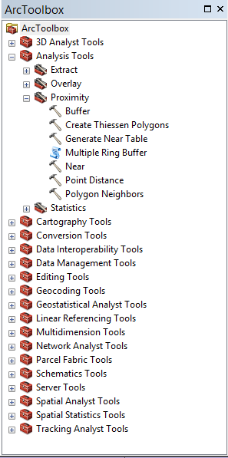

1. For *Input Features*, from the Pull-Down menu select the I-684 Layer.
2. For Output Feature Class, navigate to your Week 5 folder using the folder Icon on the right. Enter *I-684Buffer* in the name field. Select Ok
3. For Distance enter 3 and for units on the right change to Miles.
4. Select OK.
5. There are multiple circular buffers is because there are several line segments/features that make up I-684.
6. In Layout mode add Titles, etc.; make sure the colors of the layers are readable; and export as jpg: *I684Buffer.jpg*

**Setting Label scale**

Suppose I want to show labels on the Hospitals. If zoomed out, showing New York state and I turn them on, the map gets unreadable. The solution is to have the labels show only when zoomed in.

1. Set to Data View. Turn on the Hospitals, Roads and Towns Layers. Turn the others off.
2. Turn on the Hospital labels. You can see it is basically unreadable. They are too long
3. Zoom in far enough to make the labels readable. For example, on the few hospitals at the southern tip of Westchester
4. Double click the Hospitals layer name to get the Properties tabs and select the Labels tab.
5. Near the bottom select Scale Range.
6. Check “Don’t show labels when zoomed”
7. Set the Out beyond range to “<Use current scale>”
8. Select ok
9. Zoom in and out to see the effect. As you zoom out the labels disappear.
10. Save the map

**What to submit this week**

1. Please take the “Mid-Semester Survey” in the folder for this week.
2. Create a word file and include the jpegs of your maps (cut and paste). In word, Insert-->Picture, 1 per page with the name of the picture at the top (on each page). Name it *yourlastname*Location.doc

*Westchester-I684.jpg*

*I684Towns.jpg*

*WestchesterHospitals.jpg*

*I684Hospitals.jpg*

*I684Buffer.jpg*

1. Place your word document in the Assignment link in this week’s folder.

***Note. Your graded assignment will have 1 word file with 5 images***